Walk 14 Garway Hill
Last walked in May 2019

Description. A 5 km (3.1 mile) walk over common land with magnificent panoramic viewpoints. Underfoot the paths are firm and grassy.
Start. From Garway Hill telephone box, 10 miles south west of Hereford. Explorer Map 189 Grid 448250.
Directions from Tesco’s roundabout. (Turn milometer to zero). Follow the A465 to Abergavenny for a 7.2 miles and TL onto a minor road signed Garway Hill. At 8.2 miles TR at the T-Junction. At 9.3 miles TL at the next T-junction. At 10.4 miles at the hamlet of Bagwyllydiart, ignore the turning to the left and continue for 40 meters to TR signed Garway Hill. Continue along main road to park on the grass verge just before the red telephone box, total distance of 11.8 miles.

1. The Sun. Walk down the road for 50 meters. TR onto a concrete track with a house on your right displaying a weathered pub sign of 'The Sun'. Continue up the track, passing the rebuilt cottage on your right to a metal gate at the end of the track leading onto Garway Hill Common.

2. Garway Hill Common. Go through the gate onto the common. TR, and follow a fence line for the first 100 meters, then continue on a wide grassy track towards the top of the hill. As you ascend you will see ahead of you, to the left of the top of the hill, the Sugar Loaf, a triangular shaped mountain, on the southern end of the Black Mountains. It will disappear as you climb to be replaced by Ysgyryd Fawr, or Holy Mountain, as it gradually comes into view. Its geological slip can be clearly seen, which according to local Welsh folklore is where Noah’s Ark finally rested! Three quarters of the way to the top of the hill you will come to a pond on your right. It provides water for the ponies that roam the hill. TR here and follow the path to the Radio Mast at the common boundary fence.

3. Radio Mast. To got the best of the panoramic views, move to a small mound 40 meters to the left of the mast to see, from right to left – Hereford City, the Clee Hills, Wye Valley, Radnor Forrest, Hay Bluff, Hatterall Ridge, the entire eastern ridge of the Black Mountains, the Sugar Loaf, Yr Skirrid and Blorenge. Now with your back to the Radio Mast take the narrow grassy path to the structure on the top of the hill, a world war two observation tower and a trig point. You are now at 1200 ft.

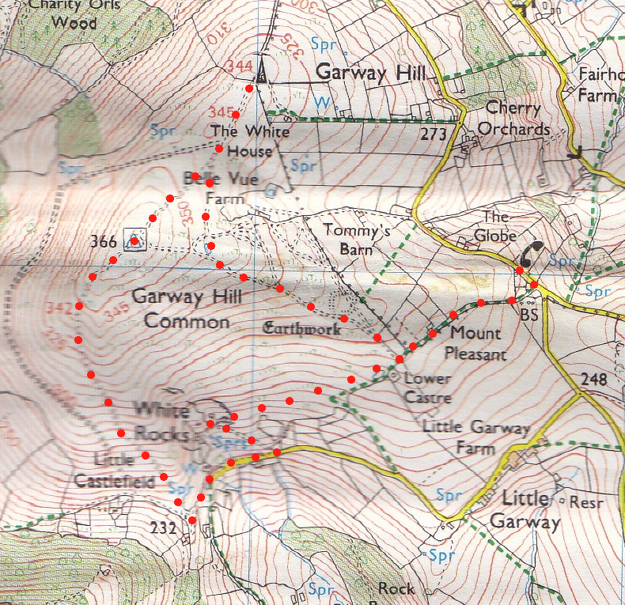
4. Top of Garway Hill. The building is the remains of an Observation Tower built in World War2 but almost immediately redundant due to the arrival of Radar. Alongside it is the Ordnance Survey Tri-angulation Point, once used for map making but now also redundant in an age of aerial photography and satellite surveying. To the West below you is Kentchurch Court, the home of the Scudnmore family who still occupy it. This is a 14thC castle, restored as an Edwardian house by Nash around 1800. Between you and the house is the deer park with its herd of fallow deer. The house was used by the BBC TV in 2004 for a series about life in an Edwardian country house. Continue on in the same direction, taking the left hand fork in the path after about 100 metres as you start travelling down hill. Keep along the ridge as you go down hill, heading in roughly the same direction, although you do veer off slightly left, and head towards a wooded area in front. This brings you out onto a stony track at the fenced boundary of the common, (and next to a wooden gate at the entrance to a house in front). TL along the stony track to join a surfaced road by a little red post box and Garway Parish notice board.

5. Chantry Cottage. TL along the road and pass White Rocks Farm building on your right to reach a cattle grid. TL immediately before the cattle grid to ascend a concrete/rocky drive for about 200 meters to the corner of a low stone garden wall on the right. Turn sharp right here to follow the garden wall to pass Chantry Cottage. Built in 1904 and with a plaque in memory of Rev. Jones who provided it, in 1929, as a place of rest and retreat for clergy. Follow the garden wall/fence uphill to the corner and just passed the wooden lodge in the garden, then slightly right as you continue straight on, in a north easterly direction, along a narrow grassy path between bracken, which after a short distance will gradually ascend. Continue up hill in the same direction and pass under some power lines as you head for the gate in the right hand corner of the common. You are now back at point 2. Retrace your stops to the start paint.
1
4
3
2
1
1
1
2
5

